**VISVESVARAYA TECHNOLOGICAL UNIVERSITY**

**“Jnana Sangama”, Belagavi-590018, Karnataka**

***A Mini Project Synopsis Report on***

**“SOCIAL MEDIA DATABASE”**

***Submitted in partial fulfilment of the requirement for the award of degree of***

**Bachelor of Engineering**

In

**Computer Science and Engineering**

***Submitted by***

**sahana s (4NN21CS046)**

**s varshini (4NN21CS043)**

**SAHANA M(4NN21CS044)**

Under the Guidance of

**Mrs. JANHAVI NANDISH**

**Assistant Professor**

**Dept. of CSE**



**Department of Computer Science and Engineering**

**NIE Institute of Technology**

Mysuru -570018

**2023-24**

## **ABSTRACT**

Through this project we are creating a basic structure of social media database. Here we are managing the data of multiple users, their follower, interests and public activity on the social media platform which includes post likes, comments, comment likes, hashtag follower, bookmarks and many more...Through our SQL query we have shown a clear cut description of connection and inter relation between different activities on social media. Here we have tried to fetch and store the data in its true storage form into this database like (img/videos in url) With our true efforts and research we have tried to give a simple and more exact view of a basic social interconnecting site. Components Schema Database ER Diagram Sample Queries.

One of social media’s greatest advantages for marketers is the ability to gather data in real-time. Social media data can help you gauge the initial success of a campaign within just a couple of hours of your launch. Over time, it provides more detailed insights about your business and your industry, so you can make the most of the time and resources you invest in social marketing.

Social media data mining also gives you key insights into your audience. You can learn what kind of content they like, when they want to see it, and where they spend their time online.

# CONTENTS OF SYNOPSIS

# 

# Introduction 1

# Objective 2

# System requirement specification 3

# Schema Diagram 4

# Entity Relationship Diagram 5

**INTRODUCTION**

What is social media data?

Social media data is any type of data that can be gathered through social media.

In general, the term refers to social media metrics and demographics collected through analytics tools on social platforms. Social media data can also refer to data collected from content people post publicly on social media. Like any business strategy, social media marketing is most effective when your goals and plans are based on real data.

Social media data analytics provide information that helps you understand what’s working. Even more important, you’ll see what’s not working, so you can make the right business decisions and refine your strategy as you move forward.

Social media data collection can help you customize your social media marketing strategy for each social network. Even more specifically, you can customize your strategy by location or demographics.

**AIM AND OBJECTIVES**

Why is social media data collection so important?

Like any business strategy, social media marketing is most effective when your goals and plans are based on real data.

Social media data analytics provide information that helps you understand what’s working. Even more important, you’ll see what’s not working, so you can make the right business decisions and refine your strategy as you move forward.

Social media data collection can help you customize your social media marketing strategy for each social network. Even more specifically, you can customize your strategy by location or demographics.

Here we have tried to fetch and store the data in its true storage form into this database like (img/videos in url) With our true efforts and research we have tried to give a simple and more exact view of a basic social interconnecting site.

**SYSTEM REQUIREMENT SPECIFICATIONS**

**HARDWARE REQUIREMENTS**

Processor : Intel(R) Core(TM) i5-1235U 1.30GHz

Clock speed : 2.5GHz

Monitor : Resolution colour

Keyboard : QWERTY

RAM : 5GB

Input output console for interaction

**SOFTWARE REQUIREMENTS**

Operating system :Windows 11 and above

Front End : HTML, CSS, JS, Angular JS

Back End : MYSQL, Java , Node.js

IDE : Jet Brains

**SCHEMA DIAGRAM**

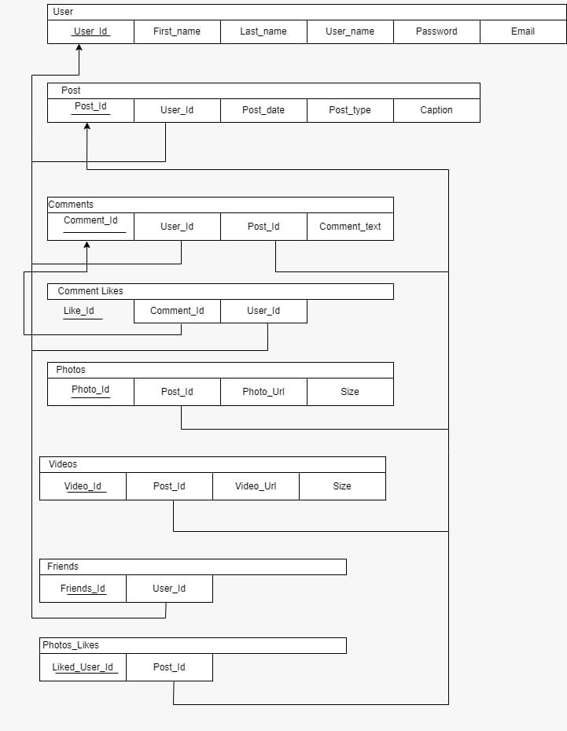

**ENTITY RELATIONSHIP DIAGRAM**

